**Table of Contents**

|  |  |
| --- | --- |
| **Section** | **Page Number(s)** |
| 1. Technical Approach and Justification |  |
| 2. Project Schedule and Milestones |  |
| 3. Management Approach |  |
| 4. Commercialization Strategy (SBIR/STTR Only) |  |
| 5 Personnel Qualifications & List of Key Personnel. |  |
| 6 Current Pending Project and Proposal Submissions |  |
| 7 Relevant Experience |  |
| 8. Attachments |  |

**1. Technical Approach and Justification:**

|  |
| --- |
| The major portion of the proposal should consist of a clear description of the technical approach being proposed. This discussion should provide the technical foundation/justification for pursuing this particular approach/direction and why one could expect it to enable the objectives of the proposal to be met. This section should include the concise technical approach in its entirety.  ***Use the following as an outline of items to include in your submission:***   * **Background:** * **Technical Approach:** * **Metrics:**  1. Baseline for comparison and how state of the art advancement will be measured 2. Beginning and ending Technology Readiness Level (TRL)   ***Include the following if applicable.***  • **Future Naval Relevance:** A description of potential Naval relevance and contributions of the effort to the agency’s specific mission.  • **Operational Naval Concept:** A description of the concept of operation for the new  capabilities to be delivered and the expected operational performance improvements.  • **Operational Utility Assessment Plan:** A plan for demonstrating and evaluating the operational effectiveness of the Offeror’s proposed products or processes in field experiments and/or tests in a simulated environment. |

**2. Project Schedule and Milestones:** Attach a POA&M (by Government Fiscal Year) that sets forth planned actions and critical milestones. 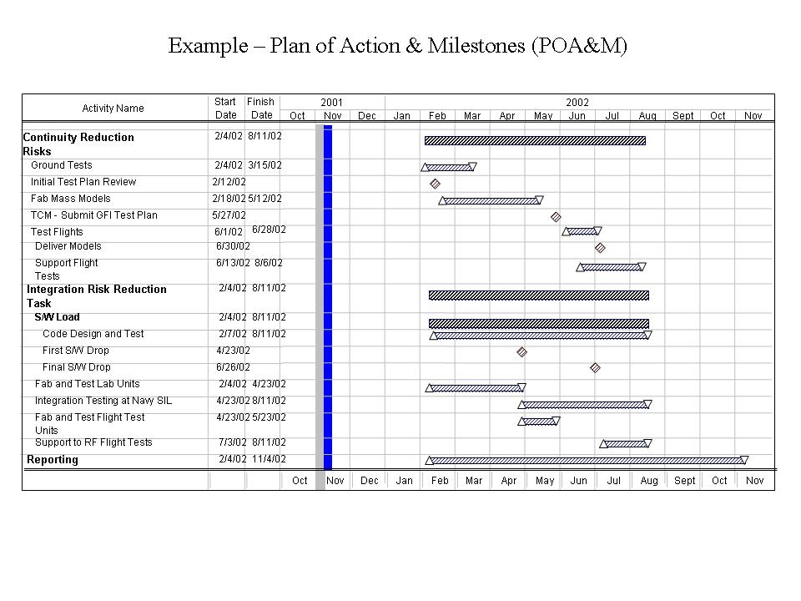

**3. Management Approach:**

|  |
| --- |
| 1.0 Discuss the overall approach of the management of this effort, such as brief discussions of the total organization; use of personnel; project/function/subcontractor/consultants relationships; government research interfaces; and planning, scheduling and control practice. |
| 2.0 Identify which personnel and subcontractors/consultants (if any) will be involved. (If there are no subcontractors or consultants include a statement to that effect.) |

**4. Commercialization Strategy (FOR SBIR/STTR Proposals ONLY):**

|  |
| --- |
| 1.0 Describe your company's strategy for commercializing this technology in DoD, other Federal Agencies, and/or private sector markets. Provide specific information on the market need the technology will address and the size of the market.  At a minimum, your commercialization strategy must address the following five questions:  (1) What is the first product that this technology will go into?  (2) Who will be the customers, and what is the estimated market size?  (3) How much money will be needed to bring the technology to market, and how will that money be raised?  (4) Does the company contain marketing expertise and, if not, how will that expertise be brought into the company?  (5) Who are the proposing firm’s competitors, and what is the price and/or quality advantage over those competitors?  Consider addressing these questions as well:   1. How much will the product/technology cost to manufacture? 2. Do you have the capability to implement a plan that will not only complete the development and testing of the product, but also addresses the full scale manufacturing and distribution of the product? 3. Will you manufacture the product or technology, license it, partner with another company or subcontract the work? 4. If you partner with another company—who, how, and when will the partners participate in this effort? Indicate if you have had previous experience with these potential partners. 5. Clarify why the approach selected will be beneficial to the Navy and/or prime contractor. |

**5. Personnel Qualifications:**

|  |
| --- |
| 1.0 Identify and discuss the qualifications of the proposed key personnel. Include the total available hours for each key person identified and note the hours each key person will commit to the proposed effort. |
| 2.0 Include resumes for the Principal Investigator and other key personnel and full curricula vitae for Principal Investigators and consultants. The resumes and curricula vitae shall be attached to this document and will not count toward the page limitations. |

**6.** **Current Pending Project and Proposal Submissions:**

|  |
| --- |
| 1.0 Have you submitted any related or complementary pending proposal submissions, including subsequent funding, to other sources (e.g. ONR, Federal, State, local or foreign government agencies, public or private foundations, industrial or other commercial organizations?  If so to whom? |

*(Do not leave out this section. If there are no pending proposal submissions include a statement to that effect.*

**7. Relevant Experience:** A description of the Offeror's Government contracts (both prime and major subcontracts) received during the past three (3) years, which are similar in nature to the effort being proposed. Include contract number and the name, phone number and email address of the technical point of contact.  **If necessary, add additional rows.**

|  |  |
| --- | --- |
| **a. Description of Effort** |  |
| **b. Name of Awarding Agency** |  |
| **c. Contract Number** |  |
| **d. Technical POC** |  |
| **e. Phone Number** |  |
| **f. e-mail address** |  |
| **g. Period of Performance (inclusive of options) (i.e.** 01 Jan 15 – 31 DEC 18) |  |
| **h. Total Award Amount (including options)** |  |
| **i. Contract Type (FFP, CPFF, etc.)** |  |
| **j. Have any options been exercised?**  **If not, why?** |  |

*(Do not leave out this section. If there are no pending proposal submissions include a statement to that effect.*

**8. List of Attachments**: Provide a list of all attachments to this document including resumes.